156

You can edit the settings editing the file: ~/.bashrc.

1. Open the file: gedit ~/.bashrc.
2. Look for the line with #force_color_prompt=yes and uncomment (delete the #).
3. Look for the line below if [ "$color_prompt" = yes ]; then that should looks like:
4. PS1='${debian_chroot:+($debian_chroot)}\[\033[01;32m\]\u@\h\[\033[00m\]:\[\033[01;34m\]\w\[\033[00m\]\$ '

Pay attention at the part \u@\h it is saying "user@host" and the number before it \[\033[01;32m\] indicates the color. This is what you have to change. For example, lets change the user to purple, the "@" to black and host to green. Edit the line so it looks like:

PS1='${debian_chroot:+($debian_chroot)}\[\033[01;35m\]\u\[\033[01;30m\]@\[\033[01;32m\]\h\[\033[00m\]:\[\033[01;34m\]\w\[\033[00m\]\$ '

Result:  
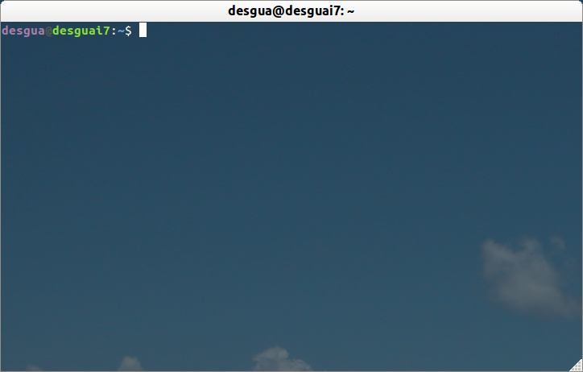

The colors numbers are:

Black 0;30 Dark Gray 1;30

Blue 0;34 Light Blue 1;34

Green 0;32 Light Green 1;32

Cyan 0;36 Light Cyan 1;36

Red 0;31 Light Red 1;31

Purple 0;35 Light Purple 1;35

Brown 0;33 Yellow 1;33

Light Gray 0;37 White 1;37

To execute ----> export PS1='${ \[\03…full line